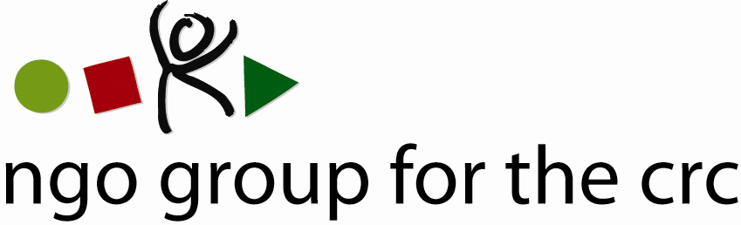

Open-ended Working Group on an Optional Protocol to the Convention on the Rights of the Child, second session, 6-10 December 2010

Compilation of joint oral statements delivered by the NGO Group for the CRC

Joint statement on Articles 7 to 13 of the draft Optional Protocol to the CRC
Delivered on 7 December by Anita Goh, Advocacy Officer of the NGO Group for the CRC

Thank you Mr Chairman,

This statement is made on behalf of the NGO Group, a global network consisting of 77 national and international NGOs.

With regard to Art 7:

We welcome the support of Sweden for our suggestion on friendly settlements. As noted by France, Slovenia and Germany, it is essential to include the possibility for the Committee to monitor friendly settlements.

We therefore strongly encourage setting additional safeguards to the current Article 7 to ensure that the interests of the victim are fully taken into consideration.

We suggest amending Article 7.2 and subjecting friendly settlements to a follow-up procedure to ensure that the terms of the agreement are implemented within a reasonable period of time. After making its good offices available, the Committee would thus have the power to examine whether the agreed settlement is implemented in respect to the Convention and/or its OPs. The Committee could then continue or re-open the consideration of communications if it considers that the circumstances justify such a course of action, as is the case in the European system, for instance.

With regard to Articles 8 and 9:

We welcome and support the provision of the time limits set in Article 8 and Article 9. These provisions will ensure a swift communications procedure and avoid unnecessary delays that would be detrimental to children’s development and well-being. This would translate in practice the importance of having a speedy procedure, as mentioned by the UK.

With regard to the proposals made regarding ESC rights:

A number of delegations have mentioned language from the OP ICESCR and have suggested including it in Article 8.

We would like to stress, however, that such a proposal would undermine the existing international practice whereby all existing communications procedures apply in the same way to the full range of rights provided by the relevant international instrument.

While the ICESCR covers exclusively ESC rights, the rights enshrined in the CRC are both civil and political rights and ESC rights, just like the rights covered in the CEDAW and the CRPD. We therefore strongly recommend that States follow the precedents of OP CEDAW and OP CRPD which do not create some unwarranted distinction when the respective Committees consider the merits of communications submitted under the CEDAW or CRPD.

With regard to article 13 on the protection measures:

One of the main outcomes of the first session of the OEWG was the need to take particular attention to the vulnerability of children as complainants.

We welcome the inclusion of Article 13 in the draft proposal and the proposal made by France and others, but are concerned that the protection measures envisaged will not be fully protective and that protection measures are only required to prevent “any form of ill-treatment or intimidation”. We believe that such a requirement is not fully protective for child complainants.

We therefore recommend that the scope of protection measures be extended to prevent any human rights violation against a complainant or his/her representative.

Thank you, Mr Chairman.
Member Organisations
- 3D Three – Trade, Human Rights, Equitable Economy
- Action for Children and Youth Aotearoa
- African Child Policy Forum
- Anti-Slavery International
- APPROACH Ltd. – Global Initiative to End all Corporal Punishment of Children
- Arigatou International
- Associated Country Women of the World
- Association for Rural Development and Action Research
- Association of Networks for Community Empowerment
- Baha'i International Community
- Child Helpline International
- Child Rights Information Network
- Child Rights Network Switzerland
- Children’s Rights Alliance
- Children’s Rights Alliance for England
- Christian Children's Fund Inc.
- Coalition Against Trafficking in Women International
- Consortium for Street Children
- Defence for Children International
- DevCon - An Association for Rural Development
- ECPAT International
- Education International
- Egyptian Foundation for Advancement of Childhood Conditions
- EuroChild
- European Association for Children in Hospital
- Every Child
- Fédération Internationale des Communautés Educatives
- First Nations Child and Family Caring society of Canada Incorporated
- Friends World Committee for Consultation (QUNO)
- Fundación Privada Intervida
- Human Rights Watch
- Inter African Committee on Traditional Practices Affecting the Health of Women (IAC-HTPS)
- International Alliance of Women
- International Association of Youth and Family Judges and Magistrates
- International Baby Food Action Network
- International Catholic Child Bureau (BICE)
- International Council of Jewish Women
- International Council of Women
- International Falcon Movement Socialist Education International
- International Federation of Social Workers
- International Foster Care Organisation
- International Inner Wheel
- International Institute for Child Rights and Development
- International Movement "ATD Fourth World"
- International Play Association: Promoting the Child’s Right to Play
- International School Psychology Association
- International Social Service
- La Voix de l’Enfant
- Maryknoll Office for Global Concerns
- National Aboriginal Islander Child Care
- National Coalition for the Implementation of the UN Convention on the Rights of the Child in Germany
- Penal Reform International
- Plan International
- Plataforma de Organizaciones de Infancia
- Proyecto Solidario
- Red Latinoamericana de Acogimiento
- Red Latinoamericana y Caribena por la Defensa de los Ninos, las Ninas y los Adolescentes
- Resources Aimed at the Prevention of Child Abuse and Neglect (RAPCAN)
- ROC (The “Right of the Child” NGO)
- Roshni Homes Trust
- Save the Children – Alliance
- Soroptimist International
- SOS-Kinderdorf International
- Terre des Hommes International Federation
- WAO Afrique
- War Child Holland
- Werkstatt Okonomie
- Women's World Summit Foundation
- World Alliance for Breastfeeding Action
- World Alliance of YMCAs
- World Association 0f Girl Guides and Girl Scouts
- World Jewish Congress
- World Movement of Mothers / Le Mouvement Mondial des Mères
- World Organisation Against Torture / SOS Torture (OMCT)
- World Union of Catholic Women's Organisations
- World Vision International
- Young Men’s Christian Association of Costa Rica

See list of members at the end of the statement

