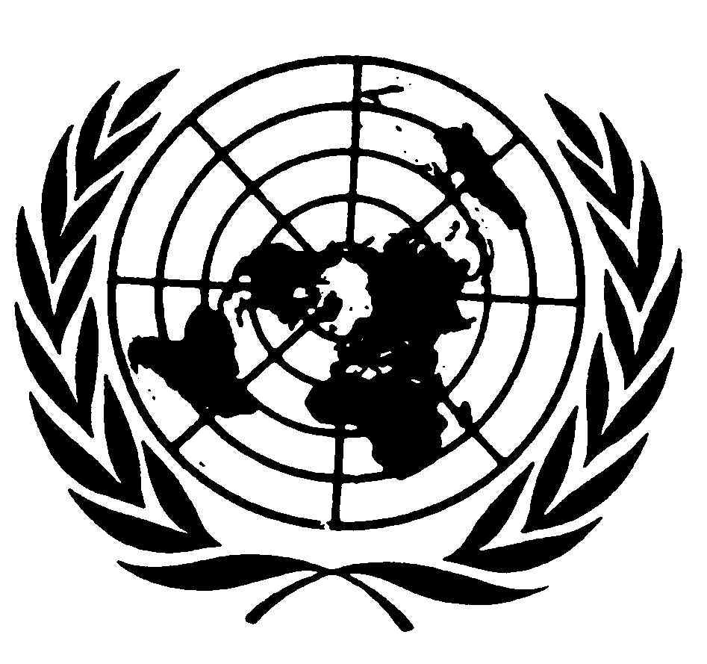

Statement by the Special Representative of the Secretary General on

Violence against Children

Marta Santos Pais

Safe Environment – Safe School

Second International Symposium on Children at Risk and in Need of Protection

Turkish Grand National Assembly, Ankara

26 April 2010
1.

It is with great pleasure that I am participating today in this Second International Symposium on Children at Risk and in Need of Protection. This important meeting, held at the time of the celebration of Children’s Day in Turkey, is a strong expression of commitment to the realization of the rights of the child, and it opens avenues for the steady improvement of children’s living conditions and for the effective protection of children from all forms of violence, abuse and exploitation.

A commemoration is always a time of celebration. And it is also a moment of reflection – reflection on the important steps undertaken and on the progress achieved in the protection of children’s rights; and reflection also on the critical areas where, in spite of our shared commitment, challenges have persisted and opportunities for change can no longer be missed. I am confident that today’s meeting will mark a turning point, helping to re-energize actions towards a society where the enjoyment of children’s rights may shape the daily experience of all children, wherever they may live.

2.
2010 is a very special year for children’s rights. It marks the 20th anniversary of the entry into force of the Convention on the Rights of the Child and the tenth anniversary of the adoption of its two Optional Protocols, respectively on the involvement of children in armed conflict, and on the sale of children, child prostitution and child pornography. These treaties have been for long ratified by Turkey and their provisions provide critical guidance to help to narrow the gap between the standards they proclaim and the reality on the ground.

These standards define States’ responsibility for the realisation of children’s rights, and they also acknowledge the role of national institutions and civil society organizations in supporting this agenda; they remind us of the imperative of always acting in the best interests of the child, of promoting equity and fighting discrimination, and of shaping a policy agenda that is informed by children’s perspectives and experience; they call for the adoption of vital protection measures to combat children’s exclusion, violence, abuse and exploitation; and by the same token, they also stress the decisive role of prevention, to address those at greater risk and the factors leading to their marginalisation and stigmatisation.
Acknowledging the increasingly interdependent world in which we live, these treaties help us realise the importance of promoting cross fertilization of experiences and of institutionalising cooperation across borders, to address trans-national dimensions of children’s rights, to be inspired by positive change and to move faster in our search for a world fit for children.

Across regions, the implementation of the Convention and its two Optional Protocols has paved the way to a significant process of social change. This process has been marked by extensive changes in national laws and policies; by the set up of high level governmental mechanisms to promote effective coordination of child related activities and to mobilise necessary resources for implementation; in several countries, independent institutions have been established to voice and serve the best interests of the child and to monitor change and policy impact on children; raising awareness of children’s rights has become part of the school curricula, and gained an increasing relevance in capacity building initiatives for professionals working with and for children; in addition, national data on children has also been steadily strengthened, helping to grant visibility to hidden areas of neglect and to give a face to marginalized children.

As a result, there has been tangible progress in children’s living conditions, with an undeniable reduction in child mortality rates, a visible increase in children’s access to school and safe drinking water, as well as in the levels of their registration at birth; and there is also a growing awareness about the many risks that hamper children’s protection from violence, abuse and exploitation.

Along these developments, the perception of childhood has also evolved. Gradually, children are being perceived not simply as vulnerable human beings and passive recipients of protection and assistance, but as agents of change. With their ideas, creativity, expectations and demands, they are being recognised in their inspiring ability to enrich our vision of the world and improve our capacity of promoting better child sensitive laws, policies and institutions. Children’s rights have gained a growing space in the political agenda and are incrementally recognised as a question of good governance and goods economics.
3.
At the same time, however, many challenges remain. The compounding factors of poverty and war expose children to disease, hunger, homelessness, exploitation and abuse. The gap between rich and poor is not closing and children are often by-passed by overall progress, with irreversible impact on their present and future lives.

Moreover, violence remains a harsh reality for millions of children around the world. Pervasive and socially accepted, it has dramatic consequences on children’s development. And it further carries with it serious social costs.

According to a recent UNICEF publication on key child protection concerns, more than 85% of children between 2 and 14 years of age experience physical punishment and/or psychological aggression. According to available research, between 500 million and 1.5 billion children worldwide endure some form of violence every year.

Dramatic as this figure may be, the reality is that violence against children remains hidden and frequently perceived as a social taboo or a needed form of discipline. As a result, there is weak reporting on incidences of violence, research is scattered and of widely diverse quality, and data collection, analysis and dissemination remain a challenge. As official statistics hardly capture the true scale and extent of this phenomenon, available information may only represent the tip of the iceberg.

To overcome the invisibility and social acceptance of violence against children, and raise awareness of its dramatic impact, the United Nations promoted the development of a global study – the UN Study on Violence against Children – and established a new official position to ensure a systematic follow to its recommendations. I was appointed into this new position of Special Representative of the Secretary General on Violence against Children only a few months ago. In my role as Special Representative, I am strongly committed to mobilise action and political support to maintain momentum around this agenda, to generate renewed concern at the harmful effects of violence on children; to promote behavioural and social change, and to achieve steady progress along the way.

I look forward to collaborating closely with you in moving this important process forward. It is critical to overcome the invisibility of violence against children and to prioritize it as a component of the national agenda. Together we can make violence against children evolve from being a concern of a few into becoming a priority for all. Together, we can give children, all children, a genuine opportunity to develop to their full potential and to assume an active and confident role in society, a society where violence has no place.

4.
Violence impacts the enjoyment of all children’s rights. It has serious emotional and health effects, it compromises children’s learning abilities and school performance, it inhibits positive relationships, provokes low self-esteem, trauma and depression; and often leads to risk-taking and aggressive behaviour and at times self-inflicted harm.

Children experience neglect and trauma as they witness domestic violence, and they further endure ill treatment and abuse, including sexual abuse, very often behind a curtain of silence and painful social indifference. Violence occurs in all settings, including where children are expected to be best protected; and it is practiced by those children trust the most, in schools, care institutions and also within the home. As a result, reporting remains rare. Children fear abandonment and reprisals from perpetrators and family members; they worry they will not be believed or will be blamed and bullied in turn; children are also unaware of where to go to benefit from protection and assistance, and in most countries they lack safe and trusted institutions where they can seek counselling or report on violence.

Girls appear to be at greater risk of sexual violence, of forced and early marriage and other harmful practices, including honour killings. In many countries, pregnant and married students are forced to leave school. Girls from poorer families and living in rural areas are most likely to be married young, as a result of social and economic pressures on their parents; they are also disproportionally victims of violence by their husbands.

Although less frequently acknowledged, sexual violence against boys is also a significant problem, including within the home. Official statistics largely under-represent the number of victims, and reporting by boys seems to be particularly hard, including as a result of shame, guilt and fear of not being believed or of suffering bullying and harassment.
5.
As stressed by the UN Study on Violence against Children, violence takes place in many settings, and the school is not immune to it. Violence in the school mirrors social attitudes, including the still frequent perception of violence as a legitimate and needed form of child discipline; and it is also affected by the environment surrounding the school, including social unrest, availability of weapons and gang criminal activities.

For many children, educational settings expose them to violence and may also teach them violence. Playground fighting, verbal abuse, intimidation, humiliation are some common expressions of this phenomenon. Bullying and physical aggression are often associated with stigmatisation and discrimination of pupils perceived as weaker or different, including children with a disability or different appearance, or belonging to marginalised groups and ethnic minorities. But these forms of violence seem to also affect a much larger proportion of children in the school system - according to a UNICEF study on child well-being in industrialised nations, which drew upon the most recently available surveys conducted with school aged children, in the large majority of the countries reviewed, more than 40% of the children had been involved in fighting over the previous year; and one third of the children had suffered bullying and acknowledged bullying others over the previous two months.

6.
In many countries, including Turkey, ill treatment and beating of children by teachers and school staff is considered unlawful and punished with disciplinary measures; in the case of some more serious forms of violence, such as sexual harassment or abuse, the outcome may be the dismissal of those found responsible.

Unfortunately, however, violence in schools remains lawful in many States, including through some serious forms of violence such as caning and whipping. And in countries where violence has been prohibited, the gap between the legal prohibition of violence and the prevailing practice remains wide and challenging.

Law enactment and law enforcement are critical to ensure a safe school environment. Legislation conveys States’ vision and ethos for the education system, and it is instrumental to promote a process through which the best interests of the child is given a priority attention at all times, and violence is not justifiable under any circumstance. Legislation is also an expression of States’ political commitment to work towards the prevention of violence and the protection of children’s dignity and physical integrity. It encourages positive discipline and the education of children through non-violent means, and it promotes conflict resolution without resorting to violence. When violence occurs, legislation is critical to protect witnesses and victims, to enable reporting and redress, and to legitimize assistance, recovery and reintegration of child victims.

For this reason, in my mandate I am advocating for the introduction in all countries of an explicit legal ban on all forms of violence against children; a legal ban applicable to all settings, including the education system. Legislation supports efforts to strengthen a safe environment in school, to overcome stereotypes, stigmatisation and discrimination; and to frame school curricula, class room management and disciplinary measures that are not based on fear, threats, humiliation and physical force.
We have learned to recognise that behaviour change does not happen by magic and does not occur as an automatic consequence of the adoption of a law, no matter how perfect the law may be. For this reason, I am also committed to supporting public information and social mobilisation initiatives to raise awareness and enhance understanding of what the law says and aims to achieve, how it can be used, and how it needs to permeate the work of institutions and shape the training and the conduct of professionals.

Violence has a negative impact on victims. It provokes anger, frustration and despair; it leads to depression and low self-esteem, paves the way to educational apathy and failure and, in the long run, may cause mental health and somatic problems.

But beyond the direct victims, violence generates fear and insecurity amongst students; it hampers pupils’ learning opportunities and children’s overall well-being; and it further raises families’ anxiety and scepticism, at times leading to pressure for children and in particular girls’ absence or abandonment of school, as a means of avoiding the risk of further violence and harm.

7.
It is critical to reverse this pattern. Schools provide an environment in which attitudes that condone violence can be changed and non violent values and behaviour can be learned.

As recognized by the Convention on the Rights of the Child, education has a unique potential to promote the holistic development of the full potential of the child. It provides an opportunity to develop creative talents and critical thinking, to gain skills and feel equipped when facing challenges in life; to socialize and interact with others, to respect and feel enriched by diversity; and to solve conflicts in a non violent manner. It also provides a unique opportunity to learn in a stimulating environment, where the content of the curriculum and the pedagogical methods nurture the child’s confidence to actively participate in the class and in school life, and help to feel respected in one’s individuality and dignity.

To achieve these aims it is important to invest in prevention, to maintain an environment where violence is not tolerated and to effectively respond to violence whenever it occurs. As stressed by the meaningful title of this International Symposium, it is critical to create a “safe environment and a safe school”.

The physical environment in the school plays a role, and so do clear policies to prevent and address violence. And clearly, people remain a critical factor of change.

In these and other related dimensions, there are good practices we can build upon. There is increasing recognition of the importance of school audits to prevent and address violence. School audits help to assess what is in place, what is needed and what works best, as well as to understand the role the school can play in promoting social inclusion, gender sensitivity and tolerance, and in minimizing and responding to situations of violence.

School audits are important to help shape action guided by evidence, rather than promoted on the basis of assumptions and ill perceptions. This is a risk we all know well. We are in fact often reminded of how public perception of school violence runs the risk of being coloured by sensationalistic media reports on extreme situations of school shooting, kidnapping and vandalism; and yet, we realise also that these are extreme events that fortunately do not represent the situation in the majority of education settings around the world.

When promoted in a strategic and participatory manner, audits can help refine the ethos and policies of the school and promote the development of clear standards and codes of conduct; they motivate and mobilise support amongst teachers, staff and, students, and they have a clear impact beyond the school, helping to sensitize and involve families and other key stakeholders in the community. School audits also help to shape counselling, mediation and victim support systems, to monitor impact and assess feedback on implementation.

Raising public awareness of the rights of the child, and very especially of children’s freedom from violence, gains a special relevance in this process, and so does its inclusion as a core component of the curricula for professionals’ training and children’s schooling. Special events, school debates, exhibitions and contests can help mainstream the values of tolerance, respect for diversity, equity and social justice, while encouraging reflections on social barriers and traditions that prevent progress in violence prevention. In many instances, schools have also set up phone helpline services, allowing children to seek advice and share their concerns in an anonymous, frank and safe manner. Not less importantly, when incidents of violence occur, inquiries are promoted to assess what has happened to address those responsible and, above all, to understand the reasons and root causes that have led to their occurrence. Only that way can new incidents be effectively prevented and impunity duly fought.

Initiatives like these ones help to nurture victims’ confidence to speak up, learning to trust and confide. Witnesses also feel encouraged to report incidents of violence. Early warning signals gain visibility and are taken seriously. And the school is perceived as an institution that cares and acts.

8.
In all these areas, joining hands with children and young people remains crucial. By listening to children’s views and perspectives and being informed by their experience, we gain a better understanding of the hidden face of violence and its root causes; we learn about the different ways in which boys and girls perceive violence and suffer its impact, and we enhance our ability to shape strategies to address persisting risks.

By joining hands with children, we become better equipped to develop child sensitive mechanisms for counselling, recovery, redress and reintegration of victims. And we can refine child friendly materials to empower children to become the first line of prevention, to promote self-esteem, and to build confidence to report cases without fear.

The school is a privileged environment to provide children with skills for the safe practice of violence prevention and peaceful conflict resolution, for managing anger and sorting out problems. Moreover, it can provide support, encouragement and recognition.

In many countries, significant child led initiatives are gaining an increasing relevance. There are promising experiences of peer supported systems designed to strengthen students’ values of tolerance, inclusion, mutual respect and cooperation, while acknowledging diversity, questioning aggression and encouraging non violent approaches. Trusted team work, befriending with colleagues, promoting mediation and solutions guided by fairness, and developing skills to listen to those in distress, support those at risk and challenge those who generate violence are some important illustrations we can all learn from.
School councils play a critical role in this regard. With the involvement of students’ representatives in school decision making mechanisms, in many cases with the responsibility of also considering disciplinary action, the councils help to institutionalise children’s right to participation, and they support children’s development, democratic experience and growing sense of responsibility. These are platforms where children learn to raise and discuss issues of shared concern, to identify possible solutions and promote critical mediation efforts, and where they are expected to act as a sensible interface and to provide feedback to their peers.

9.
Dear Friends, these few illustrations speak to the many significant developments designed to prevent and address violence within the education system. But there are also many critical initiatives being promoted beyond the school universe. Parliamentarians have been key actors in this process of change. As strong catalyst in favour of the realization of the rights of the child, they have developed expertise and helped ensure a broad support across political parties represented in Parliament, thus avoiding the consideration of children’s rights as a partisan issue.

As political leaders, many have become spokespersons for the rights of the child, raising awareness in their societies and influencing law-making in conformity with the principles and provisions of the Convention - as a result, several countries have today a legal ban on all forms of violence against children. Parliaments’ action has also been felt in the approval of child sensitive national budgets and through their support to the development of national plans on the rights of the child, or specifically on children’s protection from violence.

To remain engaged, to monitor progress and stimulate change, some parliaments hold an annual parliamentary debate on the situation of children, a debate to which they also associate representatives from government and civil society. In some countries they promote annual discussions with children, giving them a space to voice concerns, to share experiences and recommend avenues for change in violence prevention and response. Similarly, in an increasing number of countries children’s parliaments are contributing to the enhancement of children’s skills to engage and influence policy discussions, including those designed to combat violence.

With its decision to establish a Children’s Monitoring Committee, Turkey has taken a pioneering step in this area. This landmark decision is a strong tribute to children and the safeguard of their rights. The Committee lays the foundation for a strategic and innovative process of implementation of the Convention on the Rights of the Child; it legitimises and encourages children’s contribution to this agenda and, with the creation of a special website, it provides a formal mechanism to secure children’s views and perspectives for monitoring progress and influencing policies for the safeguard of their rights.

This strategic high level forum creates a unique opportunity to strengthen children’s protection from violence, within and beyond the school system; to place violence against children at the centre of the public debate and high in the policy agenda, and to break the conspiracy of silence around this phenomenon.

Dear Friends,

Across regions, children express deep concern at the unacceptable levels of violence affecting their lives. They convey fear and trauma, believing they are worthless and abandoned to their suffering. To escape aggression, humiliation and indifference, they feel pressed to run away from school, from home and care institutions. This phenomenon knows no geographic, cultural, social or economic boundaries and remains a challenge also within the European continent. Less than a year ago, adolescents across the EU Member States identified violence against children and child sexual abuse as the most serious concern confronting their lives, and the most pressing priority governments should be addressing.

At the same time, in Europe and beyond, children remain active and engaged to raise awareness and inform peers, to support victims and sensitize adults, to discuss solutions and influence change. In Europe as elsewhere, children have very high expectations on all of us!

Today’s important commemoration of Children’s Day is a time to celebrate and also a time of reflection. But it can further mark the start of a new age, an era where violence has truly no place.

