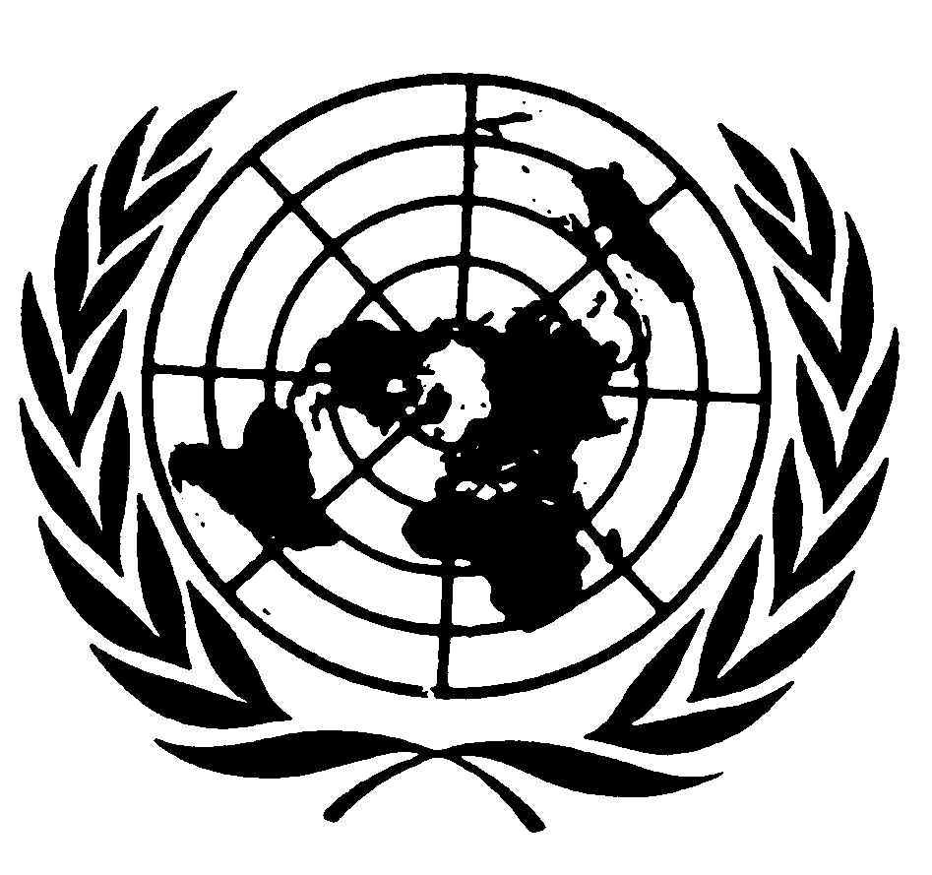

UNICEF Executive Board

Statement by the Special Representative of the Secretary-General
on Violence against Children

Marta Santos Pais

June 2010

Mr President
Distinguished Delegates
Ladies and Gentlemen
Dear Friends

I am very pleased to participate in this commemorative event of the 10th anniversary of the adoption by the General Assembly of the Optional Protocols to the Convention on the Rights of the Child. I want to congratulate you for this important initiative, which reaffirms the strong commitment of the Executive Board to support the realisation of children’s rights and, most especially, to strengthen children’s protection from violence, abuse and exploitation.

It is the first time I have the honour to address the UNICEF Executive Board since assuming the position of Special Representative of the Secretary General on Violence against Children. I am delighted this is taking place on such an auspicious occasion.

As you know, my mandate builds upon the UN Study on Violence against Children and its strategic recommendations. It is framed by a sound human rights normative foundation and is firmly anchored in the Convention on the Rights of the Child and its Optional Protocols. These treaties established a new threshold for the safeguard of children’s rights, in peace as well as in times of war. They envisage the protection of children from all forms of violence, including from sexual exploitation, not only as a widely shared ethical concern, but also as a human rights imperative. They recognise States’ accountability to protect the dignity of the child at all times; to address risk factors that compromise children’s development and citizenship; to invest in the social inclusion of the most vulnerable; and to promote a process of change that is informed by children’s best interests, views and experiences.

Promoting the universal ratification and the effective implementation of the Convention and its Optional Protocols is a priority in my work.

This is why I am joining hands with key United Nations partners in a global campaign for the universal ratification of the Optional Protocols to the Convention. In view of the nature of my mandate, I am particularly engaged in advocacy efforts to promote global adherence to the Convention and its Protocol on the Sale of Children, Child Prostitution and Child Pornography.

As you know, the campaign was launched with the Secretary General and the Executive Director of UNICEF, a few days ago, here in NY. Thus, today’s event marks the first critical stage of this two year campaign which aims to achieve universal ratification of the Protocols by 2012, the year we will commemorate the 10th anniversary of their entry into force.

By very meaningful coincidence, 2012 will also mark the first decade since the UN Special Session on Children. At that time, the international community pledged to build a world fit for children, “a world in which girls and boys can enjoy childhood, a time of play and learning, in which they are loved, respected and cherished; their rights promoted and protected, without discrimination of any kind; where their safety and well being are paramount and where they can develop in health, peace and dignity”. By achieving the universal ratification of the Protocols, we will be moving decisively closer to that ideal.

Mr President,

The Protocol on the Sale of Children, Child Prostitution and Child Pornography is in force in 137 countries. Less than one third of Member States is missing and more than 80% of them are already parties to the ILO Convention on the Worst Forms of Child Labour, which also addresses these child rights violations. Several States have formally committed to ratify the Protocol, including in the context of the Universal Periodic Review of the Human Rights Council.

The goal of universal ratification of the Protocol has also been widely endorsed in high level international conferences. It is the first commitment of the Call for Action adopted by the Third World Congress against the Sexual Exploitation of Children and Adolescents; and it was reiterated again a few weeks ago during the Hague Global Conference on Child Labour. This goal is promoted by international human rights bodies and supported by a wide network of civil society organizations.

With your support, universal ratification is within reach! Once the Protocol is in force in all countries, impunity for the sale of children, child prostitution and child pornography can be actively fought within and across borders; and prevailing loopholes in child protection systems can be effectively addressed.

Achieving progress in this area is vital and also urgent. Every year, millions of children are trafficked, enslaved through sexual exploitation, sold to marriage, illegal adoption or forced labour. These are largely hidden and clandestine forms of violence against children, but the magnitude of what is known raises our greatest concern. In its most recent global report, the ILO recognises that 115 million of children are victims of hazardous work, amongst which sale and sexual exploitation of children figure prominently.
These children are hard to capture by statistical data; but more importantly, they remain a low priority in the policy agenda, they are by-passed by social investment and excluded from the public debate. Stigmatised by society, marginalised by their communities and, in still too many countries, criminalised and deprived of liberty, they fail to be protected as children and as victims of exploitation, and are instead condemned by silence and indifference.

For these children, the time for celebration is not yet!
Today’s event provides a strategic opportunity to reverse this pattern. The discussions that will follow will no doubt provide an opportunity to learn and feel inspired by the many significant initiatives undertaken at the national level to promote the ratification of the Protocol, and to prevent and address the sexual exploitation of children.

Today’s session can also be a strategic occasion to reflect on the many areas where, in spite of strong political commitment, challenges have persisted and opportunities for change can no longer be missed.

As we know too well, ratification is only the start of a long and demanding process of implementation. In the case of the Protocol on the Sale of Children, Child Prostitution and Child Pornography, government action has been strong and steady across regions, with new laws enacted, national action plans developed, child protection systems given a new attention, and specialised units established to safeguard the rights of child victims. At the same time, civil society advocacy campaigns have helped to generate concern and mobilise action, the business sector has joined hands in the struggle, and cross border cooperation has been strengthened.

Children have also become strong advocates in this process and they ignite us with a call for urgent action. They intervene as spokespersons for the many victims, who are invisible in their experience of violence, stigma and exclusion. And they remain actively engaged to raise awareness and inform peers, to support victims and sensitize adults, to discuss solutions and influence change.

In spite of these promising developments, the protection of children from sexual exploitation remains a complex and difficult area where urgent action is required. It is critical to overcome the perception of this child rights violation as a social taboo; it is urgent to establish well resourced and child sensitive policies, institutions and services; it is indispensable to adopt and enforce legislation to criminalise the sale of children, child prostitution and child pornography and to safeguard the rights of child victims and witnesses. And it is also vital to monitor the impact of all these measures, to avoid loopholes in child protection and to effectively address evolving challenges and concerns, including those presented by the transnational nature of these crimes, by the use and misuse of new technologies, by the lack of data and research, and by the still prevailing tradition of addressing these serious crimes through reactive and fragmented actions.
The Protocol provides strategic guidance on the way forward and there are many lessons to build upon from the process of implementation of the past years. But strong political is essential to keep this topic high in the policy agenda. With so many competing priorities and the difficulties in securing funding at a time of financial and economic crisis, the protection of children from violence, and very especially from sexual exploitation, may run the risk of becoming diluted or placed in a waiting slot.
Mr President,

With the strong leadership of the Executive Board, today’s auspicious commemoration can become a lasting and forward looking reminder of the many children we have failed to protect so far.

I am confident that the Executive Board will capture the richness of today’s debate in your deliberations and, beyond today, will continue to place high in its agenda the call for ratification and implementation of the Protocols, and the protection of children from violence, including sale and sexual exploitation.

The support of the Executive Board to the global campaign for universal ratification will be a decisive encouragement to those countries that have not yet been able to adhere to the Protocols. Raising your voice in favour of this goal in regional fora will generate renewed attention and commitment. Championing this cause at the national level will help to achieve change and inspire action beyond borders.

Joining hands together, accelerated efforts towards ratification can be promoted and the community of States parties to the Protocols can be steadily increased. I am confident that, by next September, many countries will be ready to sign, ratify or accede to the Protocols and will join the UN Treaty Event, which will be organized during the General Assembly Debate. And by 2012, we will be celebrating universal ratification.

