Submission to the 62-63rd Session of the Committee on the Rights of the Child:

Report of Israel under the Convention on the Rights of the Child

15 July 2012

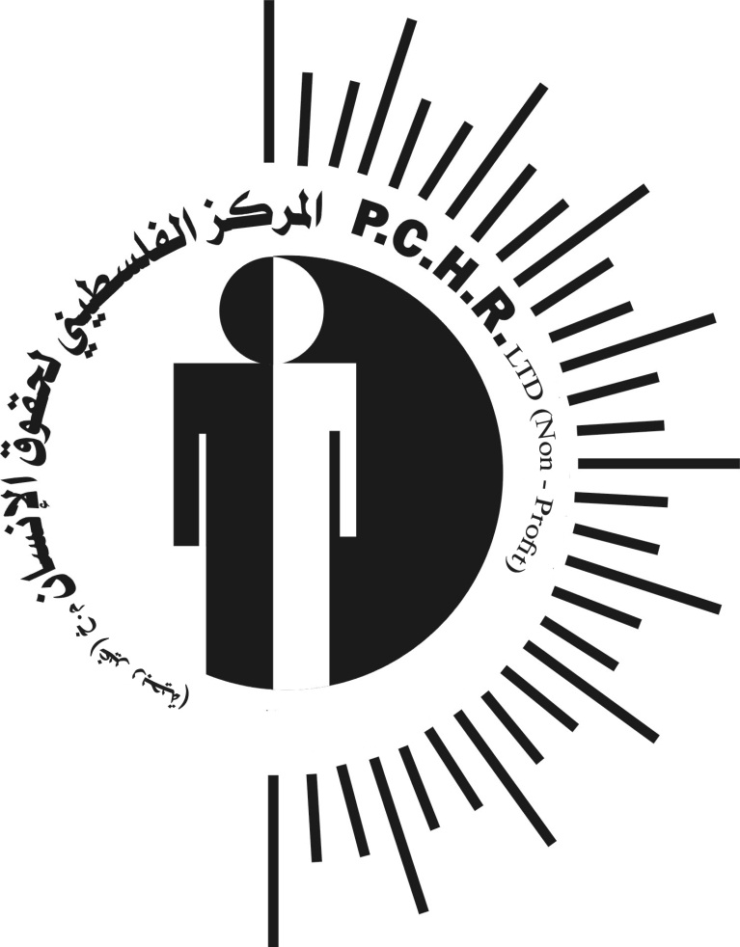

Palestinian Centre for Human Rights
Consultative Status with the ECOSOC of the United Nations
Affiliate of the International Commission of Jurists - Geneva
Member of the International Federation for Human Rights (FIDH) - Paris
Member of the Euro-Mediterranean Human Rights Network – Copenhagen
Member of the International Legal Assistance Consortium (ILAC) - Stockholm
Member of the Arab Organization for Human Rights – Cairo

Executive summary

As upheld by the International Court of Justice in its Advisory Opinion on The Wall, Israel – as the Occupying Power in the Gaza Strip – is subject to specific obligations arising from international humanitarian law and international human rights law. This includes obligations arising from the Convention on the Rights of the Child (CRC).

Israel is currently failing to respect, protect and ensure the human rights of the children of the Gaza Strip. At this time, Israel’s arrest of children in the ‘buffer zone’ and their subsequent detention is a violation of Article 37 of the CRC. Israel is failing to provide a safe and clean environment for the children of the Gaza Strip, which has a subsequent negative impact on the health of Gaza’s children in violation of Article 24 of the CRC. Israel’s attacks against school buildings in the Gaza Strip not only prevent children from gaining a proper education, but also have a negative effect on the mental health of school children, in violation of Articles 24 and 27 of the CRC. Lastly, illegal attacks launched by Israeli forces against the Gaza Strip have a significant effect on children, resulting in significant death and injury.

Introduction

The Palestinian Centre for Human Rights (PCHR) notes that Israel has failed to extend the protections required by the CRC to the children of Palestine. PCHR echoes the concerns of the Secretary-General on Children and Armed Conflict who, on 26 April 2012, noted the high number of children, in particular Palestinian children, who continue to be affected by the on-going conflict. PCHR wish to highlight a number of conflict-related issues affecting children in this submission to the CRC, focusing on violations occurring in the Gaza Strip over the last five years, thereby covering the period from July 2007 – June 2012.

PCHR notes that Israel’s last submission was in 2010 and covered from 2002 until 2010. As the cycle for the CRC is intended to be every 5 years, PCHR made the decision to focus on the past five years – from July 2007 to June 2012 – as this time period covers, in part, the time period examined in Israel’s last State Report, as well as more recent data to illustrate the continuing violation of the rights of the child in the Gaza Strip.

This report is not intended to be comprehensive, but rather focuses on the most serious violations at this time: detention; the right to health; right to education; and attacks on children. Each violation is addressed in turn and includes photos and affidavits from victims and witnesses to help illustrate the current rights violations facing children in the Gaza Strip.

Arrest and Detention

Article 37(b) of the CRC and Rule 2 of the United Nations Rules for the Protection of Juveniles Deprived of their Liberty (Havana Rules) establish that children should be protected from unlawful or arbitrary detention, and that the arrest, detention or imprisonment of a child should only be used as a measure of last resort and for the shortest appropriate period of time.

Children in the Gaza Strip are routinely subject to arrest, both on land and at sea. On land, children are arrested in the border area, often while collecting rubble and scrap metal for sale or while they are playing. At sea, children on fishing boats are arrested during raids by Israel’s naval forces.

The following table outlines the number of children arrested in the Gaza Strip over the past five years:

Table 1: Children arrested by Israel's forces in the Gaza Strip

The following two case studies illustrate the experience of young boys in the Gaza Strip, who were attacked, arrested and detained by Israel’ forces while working in the border area.

On 06 September 2009, Ayed Hazza' Mesleh Abu Hasheesh (16), from Um al-Nasser village by Beit Lahia, and four other boys (three 17 years of age and one 12) were arrested as they were herding sheep 500 meters away from the fence, north of the village:

We were grazing sheep 500 meters away from the fence. Approximately 40 Israeli soldiers suddenly came out of the bushes and took us to the border wall. They tied our hand behind our backs and transported us by bus. Then, we were blindfolded. After a while we were asked to take our clothes off and had to change into blue uniforms. They released our hands, and, after we changed our clothes, they tied our hands in the front and started questioning us. They asked me about my ID, address, work and the boys who were with me. After that, two people came and told us that we would be released. We were taken to the Erez crossing, but once we reached the crossing a quarrel erupted between the soldiers, so we were returned to the military and we were kept in detention until 22:00 on 7 September. We were transported by bus to the Karem Abu Salem crossing, southeast of Rafah, where we exited from the border gate at 3:00 on 8 September 2009. We walked until we reached the Gaza International Airport, where someone found us and brought us home.

On 10 December 2009, Mohammed Hatem Yusef Qasem ‘al-Kafarna’ (16), from Beit Hanoun, and his friend Mahmoud Jameel Hassan al-Yazji (16) were collecting rubble 500 meters away from the border fence when they were arrested by Israel’s forces:

We were surprised that Israeli army opened fire at us. We laid on the ground for 30 minutes. Then, approximately 60 Israeli soldiers surrounded us. They searched us and ordered us to take our clothes off. Then, they tied our hands. We were taken through the border fence while we were beaten with the butts of guns. We were put in a 3x3 meter room for 6 hours. We were both questioned. I was shown some pictures of people whom I do not know and was asked about them. Finally, they took a picture of me while holding a paper with numbers written on it.

Children cannot be arrested and held in detention without due regard for basic procedural safeguards, as per Article 40 of the CRC. Israel is failing to fulfill this obligation. Children in the Gaza Strip who are arrested by Israel’s forces are interrogated without the presence of a parent or guardian. Often, the parent or guardian is not notified of the child’s apprehension. Children are not provided with prompt access to legal and other assistance, as guaranteed under Article 37(d) of the CRC. In some cases, the duration of the detention period also does not comply with Article 37(b) of the CRC.

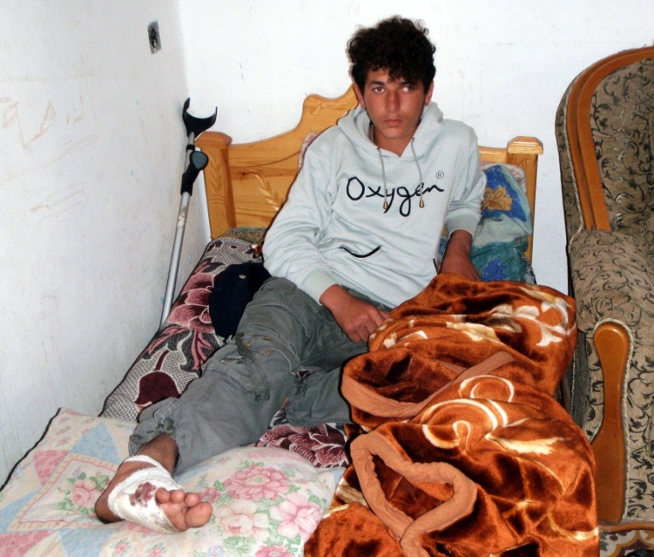
Figure 1: Mohammed al-Louh, a child fisherman who was wounded
during his arrest in March 2009.

On 10 November 2011, Mohammed Wisam Lutfi Bakr (17) was helping out on his father’s fishing boat when Israeli naval forces detained him, together with his cousin Abdul Kader Wael Bakr (17) and their uncle Arafat Lutfi Bakr (28). They were approximately 2 nautical miles off Gaza City’s shore when they were suddenly approached by a large Israeli gunboat. Without warning, soldiers began firing shots in the water around them, very close to the boat:

The bullets made the water splash up in my face. The soldiers shouted at us to take off our shirts and trousers. We had to jump into the water and swim towards them one by one. I went last. They handcuffed us with plastic straps and blindfolded Arafat. There were at least 5 soldiers. They kicked and beat me on my arms and legs. They did the same to my cousin. I’m almost sure they gave our uncle even worse treatment, but I could not see him because they took him out of our sight. [The detention centre in Ashdod] was very dirty. At some point I said I needed to go to the toilet. Then they put me in an open area where everyone could see me. There was not even a toilet.

At around 12:00, Mohammed and Abdul Kader were transferred to the Erez border crossing. The two cousins were held there and questioned until 22:30. At that point, the soldiers at the Erez border crossing called Mohammed’s father and grandfather to inform them they were releasing the two cousins:

We stopped fishing for a little while but eventually we had no choice but to get back to our work. We are attacked a lot by the soldiers. They harass us. During this year’s Ramadan they chased and harassed us seven times. It feels like they want to disturb us more during our holy month. At sea the thoughts of risks are constantly in my head. Everyone can feel the same fear at sea. It feels like watching a frightening movie. But there is no other work for us. Where can we possibly get other work from in Gaza? Even though our work is very dangerous, there is no other choice but to go back to the see because we need the money. If and when we get another boat, I will go again.

Article 37(c) of the CRC and Rules 59 and 60 of the Havana Rules provide that a child in detention shall have the right to maintain contact with his or her family through correspondence and visits, save in exceptional circumstances. Nonetheless, children in detention from the Gaza Strip are denied family visits.

Israel is clearly failing is obligations under Articles 37 and 40 of the CRC by failing to adhere to due process procedures in the arrest and detention of children from the Gaza Strip.

Health
Every child has the right to enjoy the highest attainable standard of health, including health care facilities for medical treatment, and States Parties to the CRC are required “to ensure that no child is deprived of his or her right of access to such health care services.”

Despite its duties under the CRC, Israel has consistently failed to protect the right to health for the children of the Gaza Strip. The closure of the Gaza Strip has resulted in a lack of resources and equipment within hospital and clinics. This is compounded by the fact that the Israeli authorities bar the import of certain disposables that are indispensable for medical procedures or the operating of machines.

Furthermore, as the occupying power, it is Israel’s duty to combat diseases and malnutrition in the Gaza Strip, through providing adequate nutritious food, clean drinking water and to take into consideration the hazards of environmental pollution, as per Article 24(3)(c) of the CRC.

Israel’s illegal closure of the Gaza Strip has severely impacted the development and maintenance of Gaza’s water and sanitation network. Due to a shortage of materials and spare parts, damage from the conflict and a gradual degradation of the existing infrastructure, only 5-10% of the water in the Gaza Strip meets the international standards for drinking water. The poisonous levels of nitrate, sewage infiltration, and pesticides that are found in Gaza’s network are a widespread cause for diarrhoea and gastroenteritis amongst children. The high level of nitrates has also resulted in a ‘blue baby syndrome’ in the Gaza Strip, a blood disorder which prevents oxygen from being delivered to the tissues, often resulting in convulsions and death. This unfit drinking water also causes diarrhea in children, which was estimated to be the cause of 12% of child deaths in the Gaza Strip in 2009.

Even when proper equipment is available, the fuel crisis in the Gaza Strip, caused by Israel’s restrictions on the amount of fuel that can enter Gaza, prevents the delivery of health care. The Gaza Strip currently faces 12-16 hour power cuts, daily. In June 2012, hospitals had only as much as 11% fuel reserve to function off of, placing necessary care at risk. In addition, the power cuts often cause machines to malfunction, resulting in further problems when electricity is available.

A further factor which negatively affects children’s health is the extreme poverty caused by Israel’s illegal closure of the Gaza Strip. As a result of the 5 year closure, Gaza’s economy has virtually collapsed, leaving over one-third of the workforce and half of its youth unemployed. As a result, approximately 38% of Gazans live in poverty, and over 75% of the population is food aid dependent. This is in addition to an UNRWA funded program which ensures that the 207,000 pupils at UNRWA schools receive at least a basic level of nutrition.

Many parents do not have enough money to provide their children with a sufficiently nutritious diet, despite food aid. The lack of adequate nutritious food causes stunted growth in children (10% of children under five), and anaemia (58.6% of schoolchildren and 68.1% of children 9-12 months). Poverty is also one of the reasons families are forced to drink unfit water, as they cannot afford to purchase the clean water that would prevent the diseases facing Gazan children. Until and unless Israel allows the people of the Gaza Strip to develop their economy again, the children of Gaza will continue to suffer health consequences from a man-made humanitarian crisis.

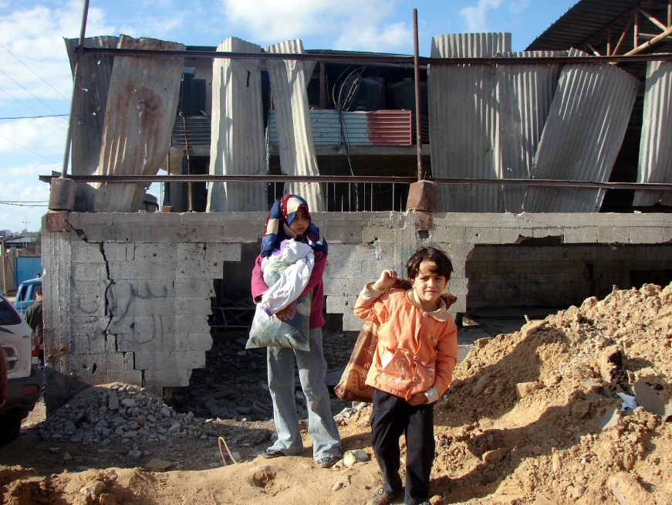
Figure 2: A home destroyed in northern Gaza during Operation Cast Lead.

During Operation Cast Lead, Israeli forces destroyed 2,114 houses (2,864 housing units), affecting 3,114 families (19,592 individuals). Another 3,242 houses (5,014 housing units) became uninhabitable as a result of partial destruction, which affected 5,470 families (32,250 individuals). Additionally, 16,000 houses were damaged. During the three week offensive, approximately 50,000 Palestinians became homeless.

The ongoing illegal closure of the Gaza Strip has also prevented materials indispensable for the construction of houses from entering the Strip, in violation of UN Security Council Resolution 1860 (2009).

The massive displacement following the assault, combined with a lack of reconstruction as a result of the closure, has resulted in many families, including children, living in crowded, unhygienic and generally unhealthy living conditions, affecting both their physical and mental health.

By failing to provide an environment where children can enjoy their right to health, primarily as a result of the illegal closure of the Gaza Strip, Israel is failing to fulfill its obligations under Article 24 of the CRC.

Education

The children of Gaza face a number of obstacles in realising their right to education, as guaranteed under Article 28 of the CRC.

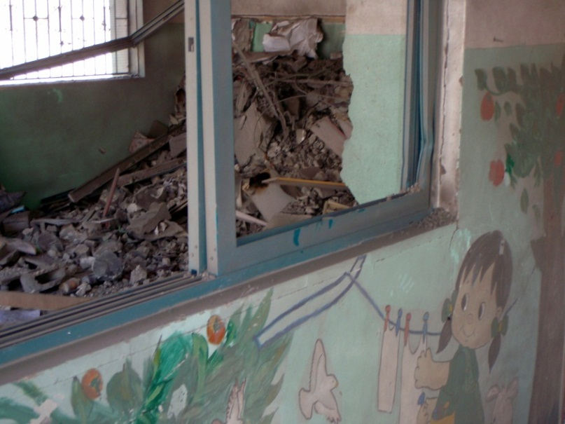
Figure 3: Salam Club, which includes a kindergarten, was destroyed in 2011.

Attacks on schools are one of the biggest problems with respect to the right to education. The following chart outlines the number of schools that have been destroyed by Israeli forces in the Gaza Strip over the past 5 years, as well as how these schools were destroyed:

Table 2: Schools destroyed by Israel's attacks on the Gaza Strip

Although attacks on schools reached an unprecedented intensity during Israel’s 23 day offensive on the Gaza Strip (27 December 2008 – 18 January 2009, referred to as Operation Cast Lead), it is clear that schools are attacked on a consistent basis. As recently as 12 March 2012, the Jabalya Martyr’s Primary School was damaged by an Israeli missile, with 350 windows, 7 doors and 3 iron gates being destroyed. This building was not being used with a military objective, and its attack cannot be justified on the basis of military necessity.

In the past, Israel has justified such attacks by claiming that Gazan schools pose a threat to their security. For example, an attack on a UNRWA school in Jabalya refugee camp during Operation Cast Lead was justified on the grounds that Hamas fighters were allegedly spotted near the building and that the UN was storing explosives in the school. As per customary international humanitarian law, schools must be protected from attack during conflicts unless and for such time that they are transformed into military objectives. If there is any doubt that an ostensibly civilian site is in fact being used for a military objective, then it must be presumed to be civilian and cannot be attacked.

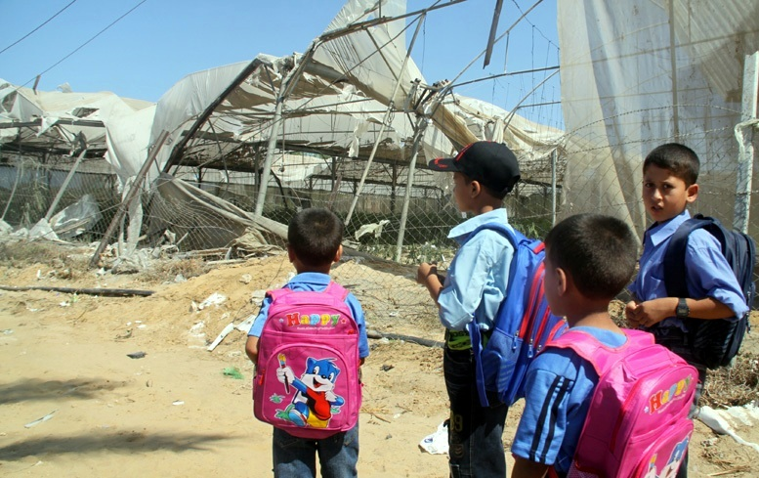
Figure 4: Children walking past destroyed greenhouses in Khan Yunis in 2010.

Due to Israel’s restrictions on the amount of construction material that may be imported into the Gaza Strip, the effects of these attacks have long-term implications on the right to education. The illegal border closure has stalled the import of construction materials for all UN agencies, who, unlike the government, cannot use the cheaper construction materials that come from the tunnels. This leaves UN agencies unable to repair damage to their educational institutions.

The high number of attacks against schools gives rise to mental health implications for the students. A study conducted with school children in the Gaza Strip shows that children no longer feel safe in school, or travelling to and from school. In fact, 57.4% of children do not feel safe at school and 66.8% do not feel safe travelling to and from school. This fear is directly connected to Israel’s attacks on the Gaza Strip, in particular their attacks on schools.

The effect of Israel’s attacks on schools therefore goes beyond the damage done to buildings. The psychological effect of these illegal attacks is a further violation of the CRC, in particular Israel’s obligation to ensure a standard of living adequate for the child's physical and mental development under Article 27 and the highest attainable standard of health under Article 24.

Attacks on children

International humanitarian law prohibits the direct targeting of civilians or civilian objects; only combatants may be subject to direct attack. The children attacked in the incidents discussed below were not combatants; they were civilians targeted in violation of international humanitarian law, in violation of, in particular, rules regarding proportionality and distinction, and, inter alia, their right to life under Article 6 of the CRC has been violated. The number of children that have been injured or killed by illegal attacks launched by Israeli forces against the Gaza Strip remains unacceptably high and these attacks must be ceased. Over the past five years, 2041 children have been injured in the Gaza Strip and 428 children have been killed in the Gaza Strip. The below chart outlines the total number of illegal attacks launched by Israeli forces against the Gaza Strip during the specified time period that have resulted in either injury or death to children:

Table 3: Attacks against children in the Gaza Strip

The numbers in 2009 are considerably higher due to the devastating effects of Operation Cast Lead. This offensive resulted in extensive civilian death and injury, as well as considerable damage to property and land.

The following chart shows the number of children (divided by boys and girls) that have been injured in the Gaza Strip as a result of illegal attacks launched by Israeli forces:

Table 4: Total number of children injured in the Gaza Strip

The following chart shows the ways in which children in the Gaza Strip have been injured as a result of illegal attacks launched by Israeli forces:

Table 5: Means by which children in the Gaza Strip have been injured

The impact of the illegal attacks launched by Israeli forces against the Gaza Strip is best described through statements provided by the victims of these incidents:

My name is Mohammed Salman Mubarak al-Sweirki. I am 17 years old. I live in Juhr al-Dik area. I started to collect iron and aluminum three days ago. This activity is the only living resource for me and for my family. I make around 60 NIS daily. At around 06:00 am on Monday, 03 October 2011, I went with two of my friends Saed Ali al-Sawarkah (17) and Ahmed Fawzi al-Sawarkah (15) to the dump site in the east of Juhr al-Dik around 400 meters from the border. I started to collect iron and aluminum ... We were nearly 500 meters from the border. At approximately 09:00 am on the same day, we were surprised by a single bullet fired by one of the Israeli soldiers who were positioned at the border. We ran away but another bullet was fired and wounded me in my left foot.

This statement is just one of many that PCHR regularly collects from children that have been injured in illegal attacks launched by Israeli forces against the Gaza Strip. The numbers of children injured as a result of such attacks has remained constant since Operation Cast Lead, in particular injuries as a result of aerial strikes, including drones. Israel must comply with its obligations under international law with respect to, inter alia, the prohibition on the direct targeting of civilians under international humanitarian law and the right to life under international human rights law.

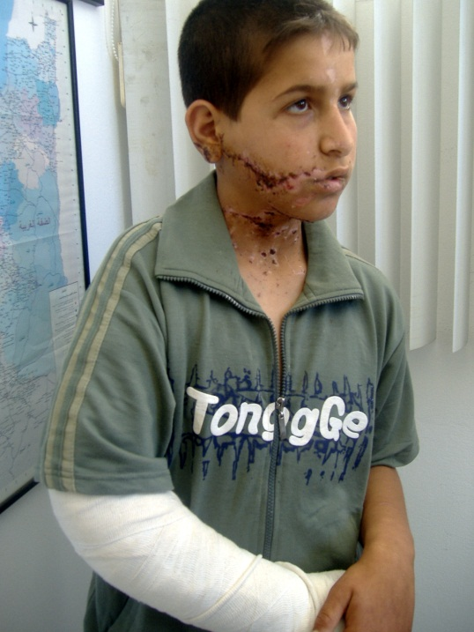
Figure 5: A child injured by a flechette.

The illegal attacks launched by Israeli forces against the Gaza Strip also results in the killing of children. The following chart sets out the total number of children that are killed (divided by boys and girls) in the Gaza Strip as a result of illegal attacks launched by Israeli forces:

Table 6: Total number of children killed in the Gaza Strip

The following chart sets out how children in the Gaza Strip were killed as a result of illegal attacks launched by Israeli forces:

Table 7: Means by which children in the Gaza Strip have been killed

Although the numbers of children killed has dropped following Operation Cast Lead, the numbers are still unacceptably high. The three deaths of children in 2012 by air strike occurred during the latest series of incidents in June. These children were not engaged in military activities, and the attack failed to target a military objective in violation of the requirements of international humanitarian law. The following statement was provided to PCHR by the father of one such victim, a young boy that was killed in air strike on 20 June 2012 while he was playing soccer in an open field. There were no military targets in the area:

At approximately 09:00 on Wednesday, 20 June 2012, I went out with my wife Amna Hasouna (50) and our only son Ma'moun Mohammed Zohdi Aldam (13) to our farm … [which] is located behind the University College in Tal al-Hawa, south of Gaza City. We approached there, had breakfast and had fun … At approximately 15:00, on the same day, Ma'moun was playing with his ball, but I asked him to stop playing because the weather was too hot. Ma'moun did not listen to me and continued playing. Suddenly, I heard an explosion that rocked the place, so I wondered what had happened as I am blind (I cannot see what is going on around me). My wife started to scream and say that Ma'moun was killed. I called for him (Ma'moun, my son, reply to me). In the meanwhile, all people gathered and told me that my clothes were blood-stained and I was wounded. I did not care about it, all I was caring about was to save my son from death … I was told in the hospital that Ma'moun had passed away.

It is clear from the above statement that the child in question was not participating in hostilities. There is no justification for attacking children like Ma'moun, or the many other children that are affected by illegal Israeli attacks.

These figures demonstrate Israel’s failure to fulfil its obligation to protect the children of Gaza’s right to life, guaranteed under Article 6 of the CRC.

Conclusion and Recommendations

PCHR strongly condemns Israel’s violations against children rights in the Gaza Strip. As such, PCHR makes the following recommendations to bring Israel in compliance with their obligations under the CRC:

- That Israel fulfils its obligations under the CRC, in its entirety, towards the children of the Gaza Strip;
- That Israel ceases illegally and forcefully arresting Gazan children, in violation of Article 37 of the CRC;
- That Israel ensures a clean and safe environment for the Gaza Strip, as well as proper healthcare to ensure that the right to health is fulfilled;
- That Israel ceases attacking schools in Gaza, which prevents children from getting a proper education. Israel must also lift the border closure so that construction materials can enter the Gaza Strip, which would allow schools to be repaired or built; and
- That Israel immediately ceases all illegal attacks against the Gaza Strip.

United Nations Rules for the Protection of Juveniles Deprived of their Liberty, 1990, Rule 2.
Statement provided by Ayed Hazza' Mesleh Abu Hasheesh to PCHR on 13 September 2009.
Statement provided by Mohammed Hatem Yusef Qasem ‘al-Kafarna’ to PCHR on 13 December 2009.
Addameer, Palestinian Prisoners: Children, available at: http://www.addameer.org/etemplate.php?id=296. Also see Defence for Children International – Palestine Section, Bound, Blindfolded and Convicted: Children held in military detention, April 2012, pg. 47 (Bound, Blindfolded and Convicted), pgs. 34-35, 41, 44-45.
PCHR, Occupied Lives: A frightening movie, 01 December 2011 (PCHR, Occupied Lives: A frightening movie).
PCHR, Occupied Lives: A frightening movie.
Bound, Blindfolded and Convicted, pg. 47.
Convention on the Rights of the Child, Art. 24(1).
WHO, Access to essential medicines and disposables in the Gaza Strip 2012, Press Release.
EWASH Advocacy Task Force, Factsheet 1: How Gaza's Blockade Impacts on Water and Sanitation, February 2011, pg. 1.
Save the Children and MAP, Gaza’s Children: Falling Behind, June 2012, pgs. 2, 17 (Gaza’s Children: Falling Behind).
UNEP, Environmental Assessment of the Gaza Strip: following the escalation of hostilities in December 2008 – January 2009, September 2009, pg. 57.
B’Tselem, Water supplied in Gaza unfit for drinking; Israel prevents entry of materials needed to repair system, 23 August 2010 (Water supplied in Gaza unfit for drinking).
WHO, Five Years of Blockade: A Political Determinant of Health in Gaza, 14 June 2012. Also see PCHR, Occupied Lives: Switching off hospitals, 14 March 2012.
The International Committee of the Red Cross has publicly stated that Israel’s policy “constitutes a collective punishment imposed in clear violation of Israel’s obligations under international humanitarian law.” ICRC, Gaza closure: not another year!, News Release 10/103, 14 June 2010.
OCHRA, Five Years of Blockade: The Humanitarian Situation in the Gaza Strip, June 2012.
PCBS, Palestinian Children – Issues and Statistics Annual Report 2011, April 2011.
OCHA, Humanitarian Situation in the Gaza Strip Fact Sheet, October 2011.
UNRWA, Gaza Strip emergency, available at: http://www.unrwa.org/etemplate.php?id=659.
Gaza’s Children: Falling Behind, pg. 2.
Palestinian Ministry of Health, National Nutrition Surveillance System, 2010.
Gaza’s Children: Falling Behind, pg. 8.
Water supplied in Gaza unfit for drinking.
PCHR, Targeted Civilians: A PCHR Report on the Israeli Military Offensive against the Gaza Strip (27 December 2008 – 18 January 2009), pg. 124.
For further details on Israel’s restriction on the import of construction materials, please consult PCHR’s website (www.pchrgaza.org), where detailed monthly reports and factsheets about the closure of the Gaza Strips borders are available.
Amnesty International, Israel/Gaza: Operation ‘Cast Lead’: 22 days of death and destruction, 2009, pg. 32. For Israel’s response see Israel Ministry of Foreign Affairs, The Operation in Gaza: Factual and Legal Aspects, 29 July 2009, paras. 336-340.
ICRC, Customary International Humanitarian Law, available at: http://www.icrc.org/customary-ihl/eng/docs/v1, Chapter 2, Rule 10.
Dr. Kathleen Kostelny and Michael Wessells, Psychosocial Assessment of Education in Gaza and Recommendations for Response, September 2010, pgs. 22-23, 72.
Statement provided by Mohammed Salman Mubarak al-Sweirki to PCHR in the presence of his father Salman Mubarak Salman al-Sweirki on 04 October 2011.
Statement provided by Mohammed Zohdi Mahmoud Abdul Nabi Aldam to PCHR on 20 June 2012.

