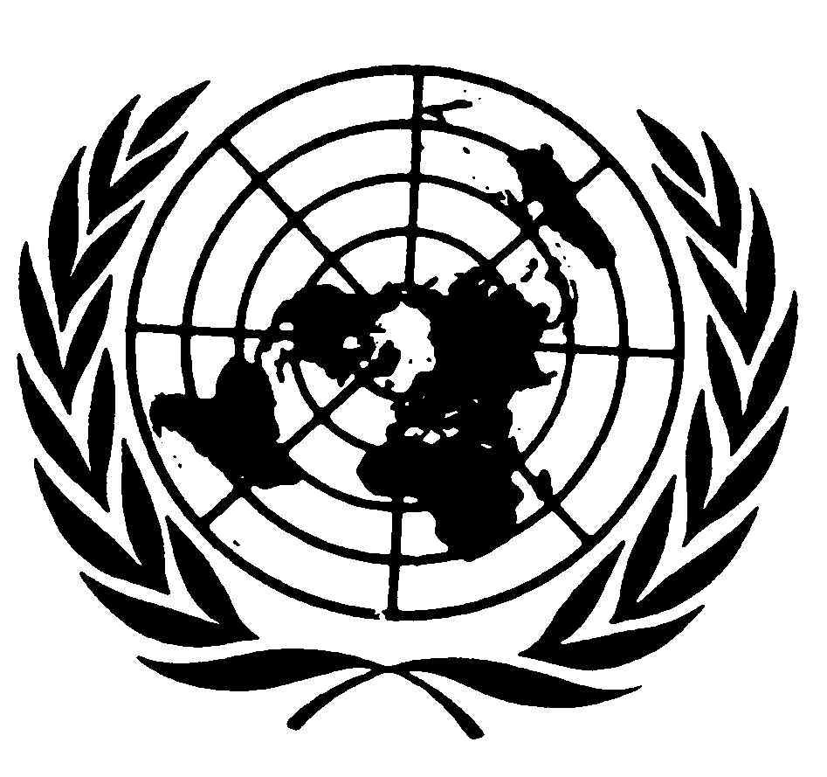

Statement by the Special Representative of the United Nations Secretary-General
on Violence against Children

Marta Santos Pais

High-level meeting on Cooperation for
Child Rights in the Asia Pacific Region

Beijing
November 2010
Excellencies,
Ladies and Gentlemen,
Dear Friends,

It is for me a great honour to participate in this High Level Meeting on Cooperation for the Rights of the Child. I want to salute you all for promoting this important regional platform, for setting in motion a strategic process of reflection and learning within the wide Asian and Pacific region, and very especially for renewing your decisive commitment to the protection of children’s rights.

This High Level Meeting takes place at a very timely occasion and during a very special year for children’s rights. Indeed, 2010 marks the 20th anniversary of the entry into force of the Convention on the Rights of the Child and the tenth anniversary of the adoption of its two Optional Protocols, on the involvement of children in armed conflict, and on the sale of children, child prostitution and child pornography. It celebrates ten years since the adoption of the Palermo Protocol against human trafficking and a decade of implementation of the ILO Convention on the worst forms of child labour. These instruments have been ratified by many countries represented here; they address key child protection questions and provide a sound foundation to improve children’s living conditions and safeguard children from violence, abuse and exploitation.

As we move steadily towards the universal ratification of these treaties and gain perspective on their implementation we recognize the significant process of change they have generated. New laws, policies and institutions have been developed to address children’s concerns; there is wider awareness of children’s rights and commitment to ensure their fulfillment; and there is also a deeper understanding of the many risks that hinder children’s development and safety.

Violence is one such critical hampering factor. Widespread and pervasive, it remains a harsh reality for millions of children around the world.

To address the dramatic impact of this phenomenon, the United Nations led a comprehensive study, the UN Study on Violence against Children, and established, a year ago, a new position to ensure a systematic follow-up to its recommendations. I am honoured to have been appointed by the Secretary General as his Special Representative to move this process forward.

Countries in this region played a decisive role in the development of the UN Study and many remain active promoters of its recommendations. I am deeply committed to collaborating closely with you in advancing this important agenda.

During the first year of my mandate I have conducted many missions, consultations and meetings at the global, regional and national levels, and have witnessed a widely shared commitment to strengthen the protection of children from all forms of violence.
Across regions, significant efforts are being undertaken to raise awareness about the dramatic impact of violence on the enjoyment of children’s rights, and to place violence against children high in the public debate and in the policy agenda. Critical initiatives within the wide Asian region illustrate this well. As captured by the background documentation prepared for this meeting, at the national level critical steps are being undertaken to shape comprehensive action plans, to enact protective legislation and to consolidate data on violence against children; at the same time, there is a growing institutionalization of regional cooperation, and increasing opportunities to promote cross fertilization of experiences, to boost advocacy and mobilize action towards the elimination of this child rights violation.

These are positive developments we need to celebrate. But persisting challenges press us to move ahead with a renewed sense of urgency and impatience.

Available research leads us to believe that between 500 million and 1.5 billion children worldwide endure some form of violence every year. Critical studies conducted in this region confirm a very high incidence of violence on children. Violence takes place in all contexts, including where children are expected to enjoy a secure environment and special protection - in care institutions, in the school and also within the home. In some communities, traditional harmful practices, including forced and early marriage, are rooted in society and hard to abandon without the genuine mobilization and active involvement of those concerned. Children experience neglect and trauma, when they witness domestic violence and also when they endure intimidation, humiliation, physical aggression, abuse and exploitation. Younger children are at special risk, having less ability to speak up and seek support, and also greater chances of suffering irreversible emotional and health damage.

Violence hurts when it happens and also leaves dramatic scars and lifelong consequences, hampering children’s development, learning abilities and school performance; it inhibits positive relationships, provokes low self-esteem, emotional distress and depression and, at times, leads to risk taking and aggressive behaviour. Beyond its impact on individual victims, violence carries with it very serious economic costs for society. In fact, responding to violence is much more costly than investing in its prevention!

Violence against children has dramatic and serious consequences, reducing human capacity and compromising social development. And yet, it remains hidden and socially condoned. Widely perceived as a social taboo or a needed form of discipline, it is seldom reported; official statistics remain limited in their ability to capture the true scale and extent of this phenomenon; and, openly or implicitly, children feel pressed to conceal incidents of violence and abuse, particularly when perpetrated by people they know and trust. A culture of silence, secrecy and social indifference surrounds this phenomenon, paving the way to pervasive impunity.

This is a pattern we urgently need to reverse. The protection of children from all forms of violence needs to evolve from being a concern of a few into a priority for all.
Guided by this sense of urgency and by the opportunity of scaling up positive national initiatives promoted in this and other regions, in my work I am particularly committed to pursue three critical goals:

- The development in each country of a national strategy to prevent and respond to all forms of violence
- The introduction of legislation to prohibit all violence against children, and
- The consolidation of data and research to inform progress in this area.

These are areas in which you have been investing and which are critical for the prevention of violence and for the development of cohesive national child protection systems. With your strong support, and by strengthening cross-fertilization of experiences within the region, these are also areas where progress can be steadily achieved.

- Firstly, it is urgent to develop in every country a cohesive, well coordinated and well resourced national strategy to address violence against children

A national strategy is more than a simple document; it sets a vision and a navigation chart, mobilizing action, resources and civil society support to prevent and respond to all forms of violence against children.

To be effective, the strategy needs to be a core component of national policy and of the development agenda, coordinated by a high level focal point with leading responsibilities on children’s issues and authority to articulate activities across departments, and periodically evaluated to assess progress and impact.

Violence prevention and children’s protection there from can be best addressed through the systematic and effective engagement of all relevant ministries and levels of public administration - from health, education and sports, to social affairs, from justice and home affairs, to planning, economy and finance. When coordination is effective and solutions benefit from the experience and expertise of individual sectors and disciplines, convergence of actions and judicious use of resources can be promoted; fragmented and reactive solutions can be avoided; and sound child protection systems can be strengthened to support children and families at greater risk; and, above all, to prevent violence altogether.

In many countries in this region significant efforts are being deployed to move in this direction. But much remains to be done to ensure that all forms of violence against children gain visibility in the public debate, and become a priority in the policy agenda and in relevant budgetary decisions. This High Level meeting opens avenues to move confidently forward.

- Secondly, it is critical to introduce in every country an explicit legal ban on all forms of violence against children

Legislation is a key component of a comprehensive national strategy. It is an expression of a country’s commitment to work towards the prevention of violence and the protection of children’s dignity and physical integrity. It encourages positive discipline and the education of children through non-violent means; provides protection to witnesses and victims, enables reporting and redress, and legitimizes assistance, recovery and reintegration.

Law reform for children’s protection from violence is gaining momentum. Around the world, 29 countries have enacted legislation to prohibit all forms of violence and many governments and parliaments in all regions are working towards this same aim. Several states have also strengthened their legislation and developed bilateral and regional agreements to combat specific forms of violence – the significant measures undertaken in this region to protect children from trafficking, sexual abuse and exploitation are a strong illustration of this important process of change.

Unfortunately however, many challenges remain and violence against children is still often accepted as a lawful practice in the education system, as a form of sentencing by judicial bodies and as a disciplinary measure in care institutions. The gap between law and practice also remains wide and challenging. Protective legislation needs to be enforced, permeate the work of institutions and shape the training and ethical standards of professionals. And it needs to promote easily accessible, child sensitive, confidential and independent counseling and complaint mechanisms for child victims.

In still too many countries, accessible and child friendly reporting mechanisms remain unavailable or ill-resourced, and professionals working with children tend to feel reluctant to address, report or refer these cases to relevant bodies and institutions. Children feel frightened to speak up and ignored and harassed when they dare to report incidents of violence. This is an area where many challenges prevail. Children need to be informed of where to go and what to do when violence takes place, they need to feel reassured that they are listened to in a safe and confidential manner, that their testimonies will not be disclosed or misused, and that their protection will not be put at further risk.

- Thirdly, research and data on violence against children need to be further strengthened

Information on violence against children is scarce and fails to represent the magnitude of this phenomenon across nations and social groups. But as recognized by significant studies conducted in this region, data and research are crucial to break the invisibility and social acceptance of violence against children, to understand social attitudes and risk factors, and to enhance the protection of those at risk.
Moreover, data and research are indispensable to support government planning and budgeting for universal and effective child protection services; and to inform the development of evidence-based legislation, policies and actions for violence prevention and response.

No policy decision is neutral to children and when accurate data and sound analysis are available, there are stronger chances of adopting strategic and well informed decisions, and of investing in prevention, rather than simply reacting to incidents of violence that have already taken place.

This is an area where urgent action is also required. Monitoring tools and indicators need to be expanded to include all children – boys and girls of all ages, and in all contexts and situations. And these efforts need to incorporate children’s views and perspectives, and be informed by their experience. This will help to gain a better understanding of the hidden face of violence and its root causes; and overall, to become more effective in our ability to prevent violence from happening in the first place.

Violence compromises the life of millions of children around the world and is associated with profound social costs. But, as we have learned from the many successful initiatives promoted in all regions, violence is not inevitable; it can be prevented and effectively addressed.

With a well resourced strategic national agenda, a strong and effective legislation and sound data and evidence to understand risk factors and inform policy decisions, a world without violence can be built.

These dimensions are crucial to the agenda of the Beijing High Level Meeting and they were also pivotal to the Millennium Development Goals Review Summit, held a few weeks ago in New York. The Millennium Review Summit will no doubt be an inspiring reference for many of the important discussions of this High Level Meeting. But in our shared commitment to accelerate progress in violence prevention and in the protection of children there from, some of the Review Summit commitments gain a very special relevance. Firstly, it is critical to promote national holistic policies to address inequity, social exclusion and discrimination and ensure universal access to public social services; secondly, it is urgent to consolidate national statistical systems and timely, reliable and disaggregated data to monitor progress and design better policies and programmes; and thirdly, if we are to succeed in fighting violence against children, including trafficking and the worst forms of child labour, it is essential to invest in cohesive child protection systems.

Your leadership and political will are essential to move this process forward. At a time of financial and economic crisis, there may be a risk of considering that children’s rights and protection from violence can be placed in a waiting slot. And yet, by investing in children and preventing violence we know well how strong the opportunity is to limit the human impact of the crisis and reduce social costs in the long run. This is why we need to urgently pursue our common efforts and capitalize on the developments promoted so far. I look forward to working closely with you in the steps ahead.

